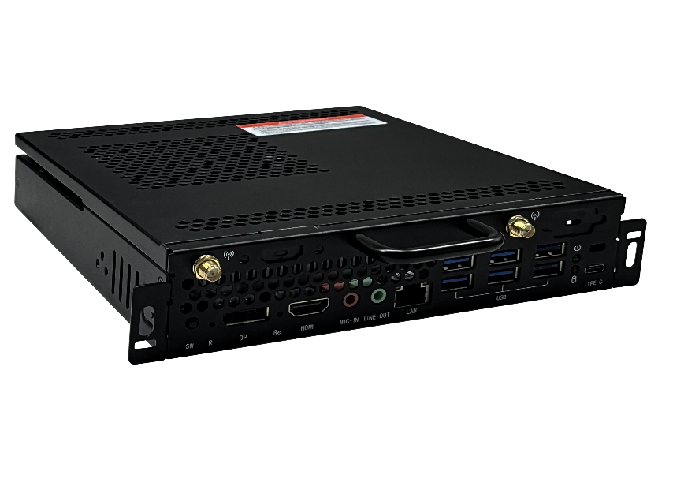

Specification parameters

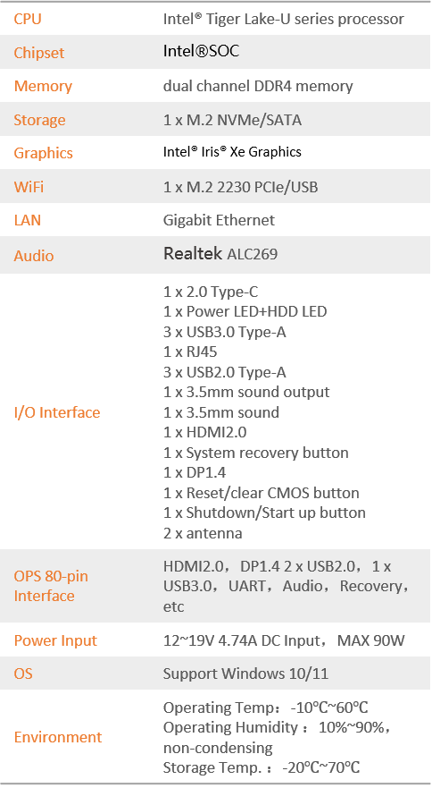

Product configuration information

* Intel ® OPS Specification
* Support Intel ® Tiger Lake-U series processor
* On board 80 pin high-speed connector
* Support dual channel DDR4 memory
* Support M.2 interface, NVMe/SATA
* M.2 interface, Wifi, Bluetooth
* Support scheduled boot, fast restore backup, PXE function

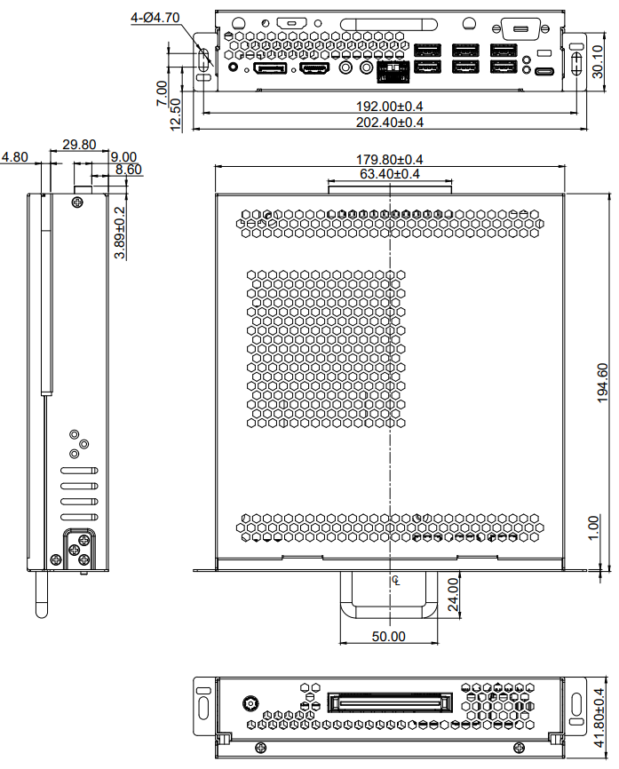

Functional features

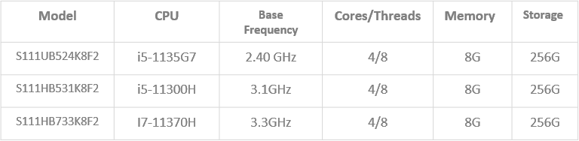

I/O Interface

